SRE Family Forum ~ Moving to Stage Four
Thursday, February 25

Questions | Answers
Connect to SRE Slide Deck for details. | Link Here  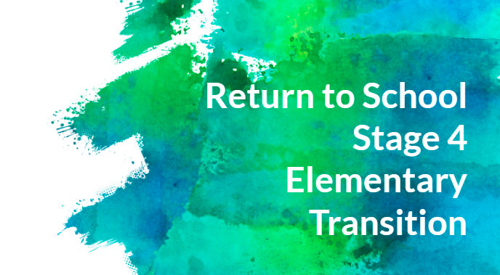
Will students return to school on March 10th? | Yes. Teachers will confirm the start date through e-mail communication and/or personal phone calls.  The only exception will be fourth and fifth grade hybrid students who are attending on Tuesdays and Thursdays. Those students will begin on March 11.
Do virtual learners work asynchronously on March 8th and 9th? | Yes. All students work asynchronously on March 8th and 9th. Students can access all activities for those two days through Seesaw.
What does instruction look like for the three days that hybrid students are not in the building? | Hybrid students will receive more conventional tasks during asynchronous days that include paper and pencil activities as well as hard copies of books they are reading. They may also use technology to access Specials, ST Math and Seesaw tasks.  Additionally, students can reference their personal agenda for those days which will outline expectations and activities to be completed.
What will Specials look like for asynchronous days? | Specials will be offered to all students through a Choice Board menu structure. They can choose between a Physical Education, Music and Art activity each day in their Seesaw account.  Choice Board activities will be pre-recorded by Specials teachers and will include instructions and materials needed. Students may access these as often as they like and when it is convenient.
Review of mask requirements | Masks are worn throughout the day, except for when students are eating and drinking.
What is the structure of the classroom? How will they look? Are guidelines in compliance with CDC? | Classrooms will be equipped with desks and chairs that are six feet apart. Students will also have a personal resource box that is large enough to hold their books, manipulatives and personal school supplies.
Is there still an option for virtual instruction? | During Stage 4 there is an option for virtual instruction at each grade level. The structure for this delivery model will be the same as Stage 3.
Will virtual learners still have scheduled times for Specials? | Virtual learners will be able to choose when they want to engage in each Specials activity. They will select from a Seesaw Choice Board.
What will Arrival and Dismissal look like? And how do we get a sign for Arrivals/Dismissals? | See slidedeck for details.  Families who are driving students to school will follow grade level signs in the school drop-off and pick-up line.  Family signs to be placed on the dashboard of each car will be distributed during pick-up on the first day back, March 10th. (Or 11th for some fourth and fifth graders.)
Is there an option for a student to be dropped off earlier than 7:45am? | At this time, the earliest drop-off is 7:45am.
What is the policy for parents/visitors during the school day? | During Stage 4, we will only have students and staff in the building.
Is ACPS thinking about tents for outdoor lunches?  Would it be helpful to have large pop-up tents? | This option was explored. Funding is not an issue, but instead a supply chain delay that impedes delivery until the summer. There is no current plan to secure tents for this spring, but we will continue to explore as the weather warms..
Are there discussions about switching to a new phase after spring break? | We have not heard discussion about a new phase after spring break.
Will students be provided lunch if they do not have one? | Yes. Teachers will ask at the beginning of the day and provide lunches to those students who request one.
What if students have a fever? | SRE has two clinics. If students have a fever they will have access to one of the clinics until a parent is able to pick them up from school.
What will bus loading and unloading look like? | There are 13 buses and they will dismiss students one at a time. After exiting the bus, the students move in a single line, six feet apart, to the entrance where their temperature is checked.  Once the temperature is taken, students follow arrows through the hallway to their classroom.
What is the protocol if a student arrives at school with a fever? | Nurse Digges will ask the student to remain in one of the two clinics and a family member will be called to come pick the child up from school.

